Cape May County
Civil War Round Table

﻿ April 21st Meeting (in person meeting)
7 PM in the Museum Barn
Presentation - "The Life of John Singleton Mosby - Commander of the Virginia Confederate Calvary - known as Mosby's Raiders"
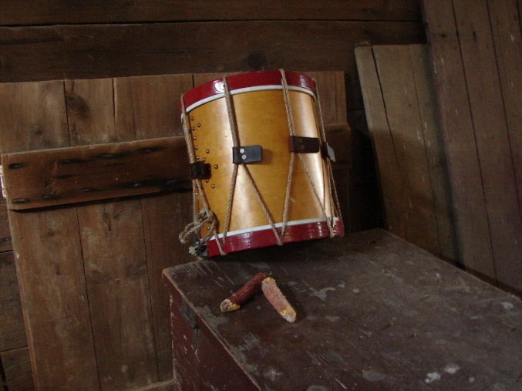

Book Raffle : We will be raffling off two books in April compliments of Simon and Schuster.
- Lincoln and the Fight for Peace by John Avalon. In this groundbreaking and revolutionary book, CNN senior political analyst and anchor John Avalon explores Lincoln’s fight for peace, and how his character informed his commitment to unconditional surrender followed by a magnanimous peace.
- Salmon P. Chase, Lincoln’s Vital Rival by Walter Stahl. Best remembered as Lincoln’s rival for the Republican nomination in 1860 – there would NOT have been a national Republican Party, and Lincoln would not have won the presidency if it were not for the vital groundwork Chase laid over the previous two decades.
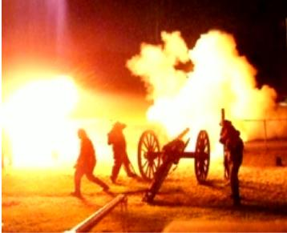

Round Table Officers 2022

President: John Herr
241 80th St., Avalon, NJ 08202
609-636-2551
avalonjohn@aol.com

Vice President: Lou Bishop Jr.
21 Schoolhouse Ln, Cape May Court House, NJ 08210
609-463-9277 or 741-5438
louiebish22@gmail.com

Treasurer: Hank Heacock
105 S Dennis Rd, Cape May Court House, NJ 08210
dianeruth54@hotmail.com

Recording Secretary: Bill Buchanan
140 74th St. Sea Isle City, NJ 08243
610-585-3585
Billbuchanan@comcast.net

Preservation Fund Raising Chair: Andy Lolli

Newsletter Editor: Jim Marshall
202 Bartram Ln, Ocean City NJ 08226
609-602-3243
jim@jimocnj.com

The Cape May County Civil War Round Table is proud to present the names, dates and topic of an outstanding cast of speakers for 2022. I am pleased at our good fortune of receiving commitments for the majority of our meeting dates. Our "dance card" is now nearly full. All these presenters are widely recognized and highly regarded Civil War historians, educators, authors and speakers. Please write these dates on your calendar and plan to attend as many as possible. This is a unique collection of speakers and an opportunity that "history buffs" do not want to miss.
Let's keep history alive with a good turnout at the meetings. This will encourage future speakers to make the journey to our round table in Cape May County. These speakers all travel long distances for a small honorarium. Anyone interested in understanding history will enjoy attending. The meetings are open to the public, so please pass this email to friends and relatives. All meetings are the third Thursday of each month, April thru November at 7PM in the Cape May County Historical Museum on Route 9.
Please become a member. Individual memberships are $30 and family memberships are $40. All student members are free.
John Herr - President
April 21 - "The Life of John Singleton Mosby - Commander of the Virginia Confederate Calvary - known as Mosby's Raiders"
Speaker Eric W. Buckland is a Retired Lieutenant Colonel with a 22-year US military career in Special Forces, a graduate of the University of Kansas and author of several books on John Mosby and his men. He is a well-known Civil War expert having spoken several times on the C-Span History Channel
May 19 - "General Lee's Two Invasions of the North - Antietam in 1862 and Gettysburg in 1863 - similarities and differences"
Presenter Brad Gottfried, Ph.D. is a retired college president, professor and administrator. He has authored 16 Civil War books including two about the New Jersey and Philadelphia brigades who fought at Gettysburg. Brad is a licensed Gettysburg Town Guide and a Certified Antietam Battlefield guide
June 16 - "No Turning Back - The Rise and Decline of U.S. Grant"
Speaker Jerry Carrier is President of the Delaware Valley Civil War Round Table and an instructor at Manor College
July 21 - "General Lee's Missing Calvary - Jeb Stuart's Whereabouts Before and During the Gettysburg Battle"
Historian Scott Mingus is a retired scientist and executive from the paper/pulp industry where he helped develop the adhesives for the US postage stamp and bar-code labels. He graduated from Miami University. Scott frequently appears on C-SPAN, C-SPAN3, PCN and other networks and has authored 26 Civil War and Underground Railroad Books. Additionally, Scott writes a blog on Civil War History.
August 18 - "Walt Whitman's Contributions to the Civil War Effort: Including his time at Washington Hospitals - Where he Witnessed the Bloody Aftermath of the Battles"
Speaker Joe Wilson is a member of Olde Baldy Civil War Round Table. He is an accomplished historian, lecturer and Civil War filmmaker
September 15 - "Kansas Abolitionist Warrior and Civil War Soldier: James Montgomery"
Speaker Bob Connor is a Phi Beta Kappa graduate of New York University, a retired journalist and has received numerous awards for published Civil War books.
Other Civil War Related Events:
- 160th Shiloh Reenactment : April 23-24, Daniel Lady Farm , Gettysburg. http://danielladyfarm.com
